1. We have elaborated our background work [1], [2], [3] and added two new work [7], [8].
2. All mismatched fonts have been matched.
3. All reference figures, tables are added through entire paper.
4. LSTM architecture is added in our report as figure 4.2 .
5. All paragraphs are justified.
6. In table 5.5 the value of recall and f1-score was same because we used micro average recall and f1-score. It does not consider each class individually, It calculates the metrics globally. When we are calculating the metrics globally all the measures become equal.

Now, we use weighted precision. recall and f1-score in our code. Unlike Micro, it takes a weighted mean of the measures. The weights for each class are the total number of samples of that class.

1. We have added the discussion part with the result analysis and unexpected performance of the results is discussed.
2. Fonts in our report is Times New Roman’ and formatting is 11 now.
3. Because of putting weighted average precision, recall and f1-score and run the code again the confusion matrices are change. So, we fix the result again and these results are correct now.

**Previous Confufion Matrics are**:

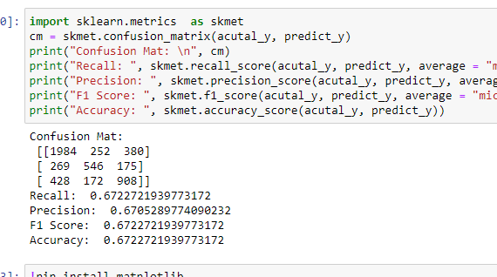

**Figure 1:** Previous confusion matrics for Decision Tree Classifier

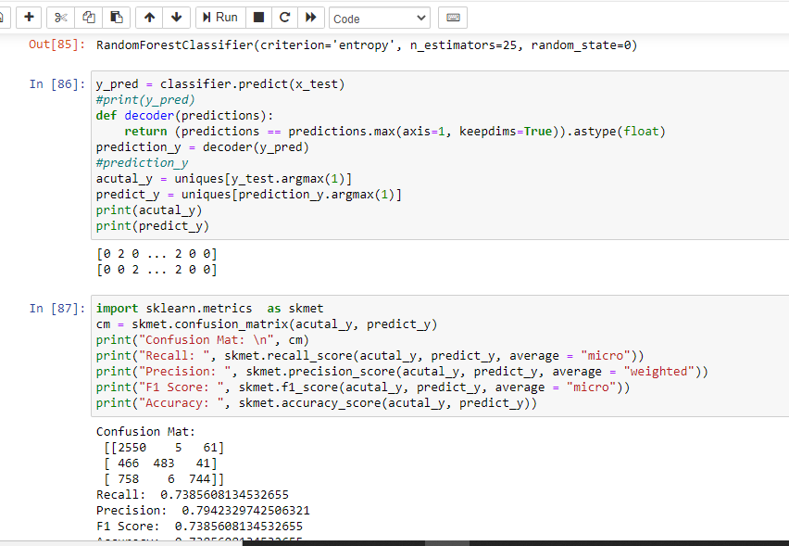

**Figure 2**: Previous confusion matrics for Random Forest Classifier

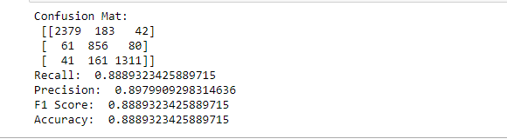

Figure 3: Previous confusion matrics for LSTM Classifier

**New Confufion Matrics are**:

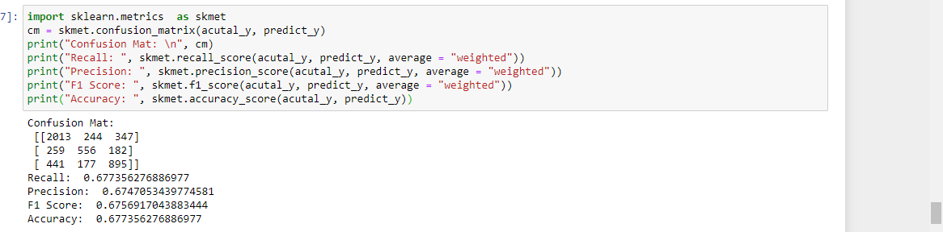

**Figure 4**: New confusion matrics for Decision Tree Classifier

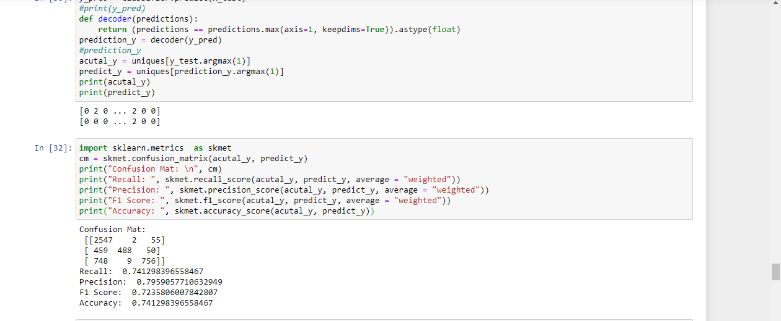

**Figure 5**: New confusion matrics for Random Forest Classifier

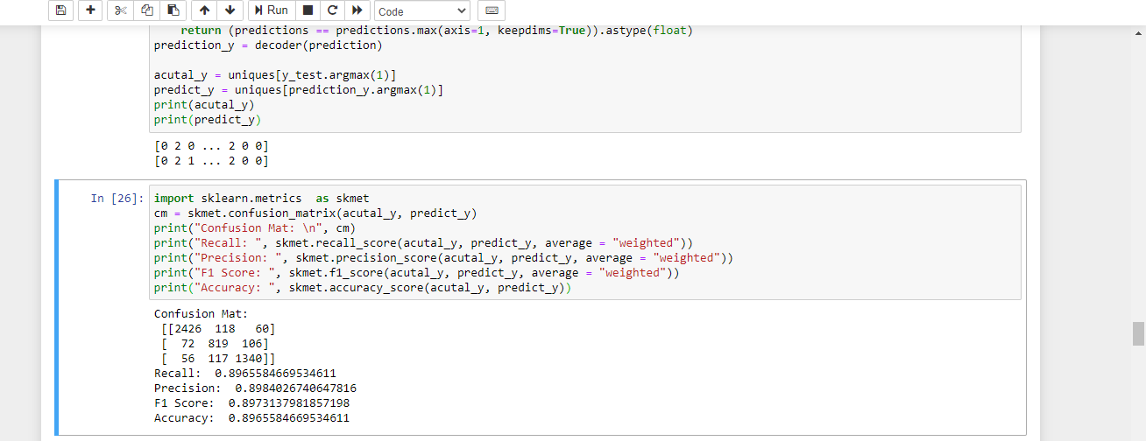

**Figure 6:** New confusion matrics for LSTM Classifier